Grant-funding Proposal
Student Name
Institutional Affiliation
Due Date

Grant Types
Program and Project Grants
Program and project grants are some of the most common classes of grants. These are granted to aid in realizing particular projects or supporting programs. These grants are mostly used in the funding of materials and other supplies required for the success of the program. In other scenarios, program grants are appropriate for supporting salaries for the concerned people. This should however be clarified with the funder because some of the program grants specifically forbid using grants for compensation.
General Operating Grants
General operating grants can also be known as unrestricted grants and are made to fund infrastructure, transpiring essentials, and the people concerned with the operation of the beneficiary. These grants can sometimes be used in improving technology.
Capital Grants
Capital grants are a type of grants that provide funds for building construction including building refurbishment or renovation, maintenance, or purchasing of building land. These grants can also help in purchasing substantial equipment.
Capacity Building
Capacity-building grants assist in financing the costs of developing organizations and keeping them operational. This funding helps in the operations such as training, strategic planning, coaching, and human resource as well as the management systems of the organization (Davis, 2003).
Endowments
Endowments refer to funding for frequently withdrawing funds. Most organizations such as non-profit organizations, educational organizations, and higher education institutions use endowments to settle growing costs and transpiring essentials.
Program and project grants and general operating grants are examples of possible sources of funding for the crime prevention program.
Funding Agencies
Examples of funding agencies include:
- Local Law Enforcement Block Grant – offers funding to local units to undertake programs that minimize crime and enhance public safety.
- National Criminal Justice Reference Service, Grants, and Funding – provides grants to the Office of Justice Programs
- Office of Community Oriented Policing Services Funding – offers a grant to law enforcement organizations
- Office of Justice programs Crime Identification Technology Act – provides aid in enhancement and implementation of efficient tribal, local, and state justice systems
- The Do Right Foundation – the foundation is interested in crime and law enforcement
- James H and L, DeVries Charitable Foundation – offers support to numerous fields including public safety and justice domains.
- Lester E. Kabacoff Family Foundation – an independent organization that offers grants in the public safety and crime fields.
- Linnell Foundation – independent foundation involved in crime and public safety
- Robert Hemingway Foundation – provide funding for crime and law enforcement
Teamwork strategies
Frequent communication
Frequent communication will be necessary for the team to function properly and to be productive. Frequent communication will also minimize duplication and confusion. Different ways of ensuring frequent communication include establishing different communication forums and training the team on interpersonal communication skills (Parker, 2011).
Leadership support
The leadership team will be the champions of doing the proposal by setting the tone for the team through their example. The leaders will also provide guidance and leadership to the rest of the team.
Establishing team rules
Rules will be established to ensure that all the team members are in alignment with what is required of them. The rules will ensure the success and productivity of the team. The rules may include meeting time and mode of the meeting which can be strictly physical or virtual.
Focusing on strengths
We will avoid dwelling on the weaknesses of the team which may lower their productivity. Using their strengths will encourage them to engage in their assigned duties or responsibilities. Combined strengths will result in success.
Outlining rules and responsibilities
Everybody in the team should understand clearly their roles and responsibilities to reduce confusion and minimize the time used to organize and delegate work since each member understands their task and can therefore focus on it.
Allowing team members to participate in decision making
Involving the team members to participate in decision-making will help in generating and adapting to the best ideas for planning as well as creating a sense of ownership.
Logic Model
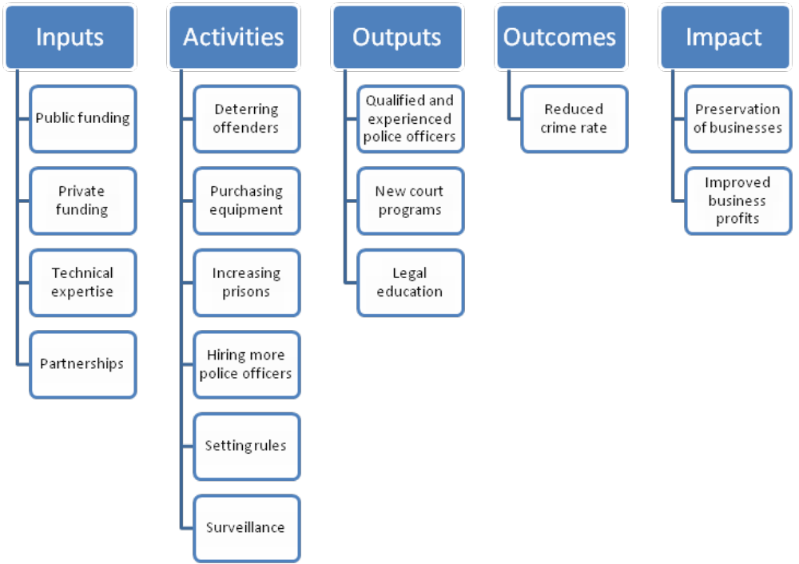

Percentage of the success of the proposal

The resources required for the implementation of the crime prevention program include public and private funding, technical expertise, and partnerships. The project expects to obtain its major funding from public funding (state funding) to finance the activities including the hiring of technical expertise to secure businesses and reduce the rates of criminal cases. Public funding will play a major role in achieving this goal by providing funds for the purchase of equipment, hiring, and training. The technical expertise will also play a major role by operating to control the criminal cases in the community.

References
Davis, B. (2003). Writing a successful grant proposal. Minnesota Council on Foundations.
Parker, G. M. (2011). Team players and teamwork: New strategies for developing successful collaboration. John Wiley & Sons.

